After Recording, Return To:
William P. McLean
McLean & Howard, L.L.P.
901 S. Mopac Expressway
Building 2, Suite 225
Austin, Texas 78746

OXBOW ON THE GUADALUPE
DESIGN GUIDELINES

Comal County, Texas

Declarant: Kona Coast Venture, Ltd., a Texas limited partnership

Cross reference to that certain Declaration of Covenants, Conditions and Restrictions for Oxbow on the Guadalupe, recorded as Document No. _____________, Official Public Records of Comal County, Texas.

ARTICLE I
INTRODUCTION

1.1 Background. Oxbow on the Guadalupe is a master planned community located in Comal County, Texas (the “Property”). Kona Coast Venture, Ltd., a Texas limited partnership (the “Declarant”) has a substantial interest in ensuring that improvements within the Property maintain and enhance Declarant’s reputation as a community developer and do not impair Declarant’s ability to market and sell all or any portion of the Property. As a consequence thereof, Declarant acts solely in Declarant’s interest and shall owe no duty to any other Owner or to the Association.

1.2 Interpretation. In the event of any conflict between these Design Guidelines and the Declaration, the Declaration shall control. Capitalized terms used in these Design Guidelines and not otherwise defined in this document shall have the same meaning as set forth in the Declaration.

1.3 Governmental Requirements. Governmental ordinances and regulations are applicable to all Lots within the Development. It is the responsibility of each Owner to obtain all necessary permits and inspections. Compliance with these Design Guidelines is not a substitute for compliance with the applicable ordinances and regulations. Please be advised that these Design Guidelines do not list or describe each requirement which may be applicable to a Lot. Each Owner is advised to review all encumbrances affecting the use and improvement of their Lot prior to submitting plans for approval. Furthermore, approval by the ACC should not be construed by the Owner that any Improvement complies with the terms and provisions of all encumbrances which may affect the Owner’s Lot. Certain encumbrances may benefit parties whose interests are not addressed by the ACC. The ACC shall bear no responsibility for ensuring plans submitted comply with any applicable building codes, zoning regulation and other government requirements. It is the responsibility of the Owner to secure any required governmental approvals prior to construction on such Owner’s Lot.

1.4 Amendments. The Board may amend, modify, or restate these Design Guidelines as provided in the Restrictions. All amendments shall become effective upon recordation in the Official Public Records of Comal County, Texas. Amendments shall not apply retroactively so as to require modification or removal of work already approved and completed or approved and in progress. It is the responsibility of each Owner to ensure that they have the most current edition of the Design Guidelines and every amendment thereto.

ARTICLE II
ARCHITECTURAL REVIEW PROCESS

2.1 Objective. The objective of the review process is to promote aesthetic harmony within the Provence community by providing for compatibility of specific designs with surrounding buildings, the environment and the topography. The review process strives to maintain objectivity and sensitivity to the individual aspects of design.

2.2 Review Process. Requests for approval of proposed construction (both new home and improvements to existing homes), landscaping, or exterior modifications must conform to the review process described in the “Design Review and Approval Process” section of these Design Guidelines.

2.3 Responsibility for Compliance. An applicant is responsible for ensuring that all of the applicant’s representatives, including the applicant’s architect, engineer, contractors, subcontractors, and their agents and employees, are aware of these Design Guidelines, the Declaration and all requirements imposed by the ACC as a condition of approval.

2.4 Inspection. Upon completion of all approved work, the Owner must notify the ACC. The ACC may, but is not obligated to, inspect the work at any time to verify conformance with the approved submittals.

ARTICLE III
DESIGN PHILOSOPHY

3.1 Introduction and Design Objectives. The Design Guidelines set forth herein are intended to provide guidance for all new homes, additions, site work and landscape improvements at Oxbow on the Guadalupe, so as to create a cohesive identify for the community. The design criteria set forth in these guidelines provide the parameters for the landscaping, lighting, signage and the exterior design of all buildings within the community. All improvements will be reviewed by the “Architectural Control Committee” or “ACC” for Oxbow to ensure that the proposed designs are compatible with this document’s design criteria. No improvement may be constructed within the Oxbow Community without the advanced written approval of the Declarant, in its capacity of the ACC.

Oxbow is a large lot, riverfront community located in Sattler, Texas on the Guadalupe River. It is designed to offer a comfortable and relaxed experience, with connections and respect of the natural environment.

Home designs for Oxbow shall:
- Coordinate landscape designs that extend native planting throughout the project, and leave large areas in a natural state.
- Incorporate designs that are contemporary interpretations of the Hill Country style, emphasizing simple character, deep shade and the use of natural materials.

3.2 Community Wide Design

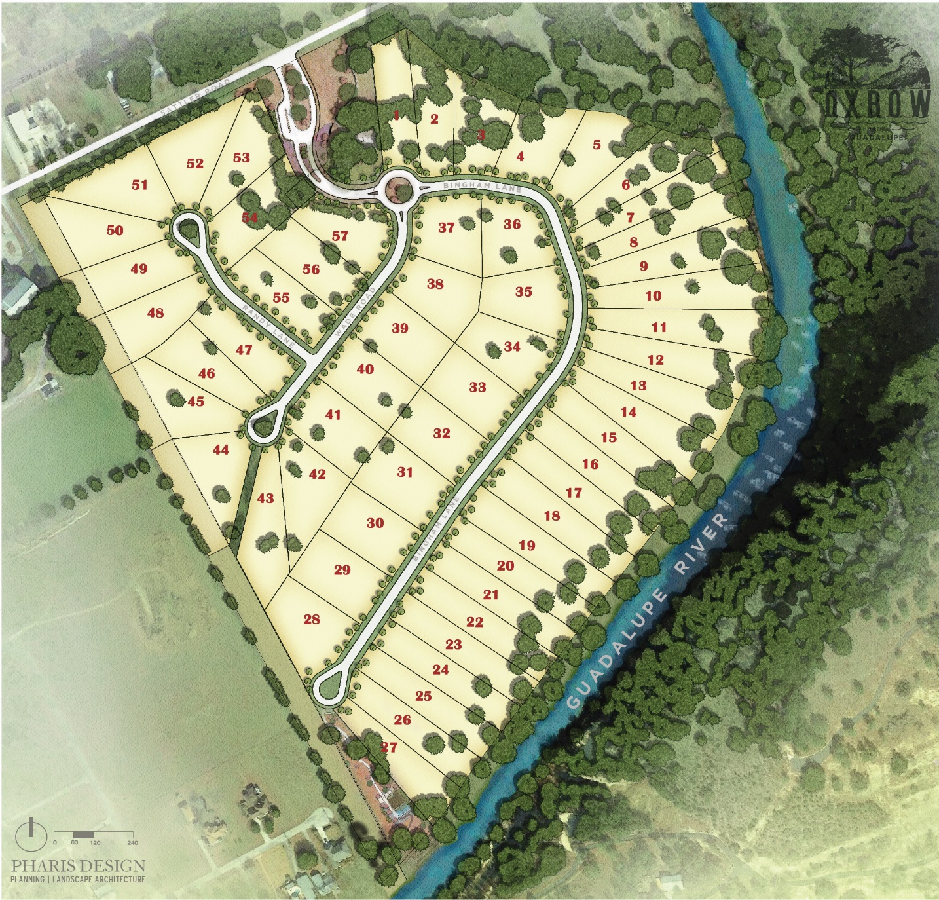

3.3 Overall Lot Shell Exhibits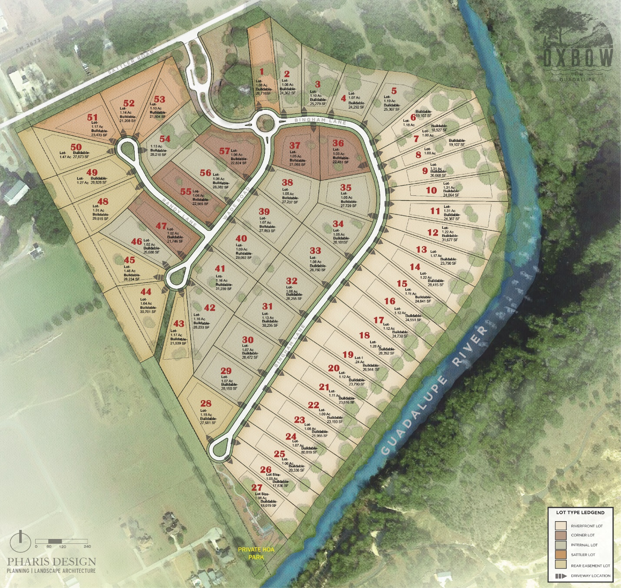

3.5 Overall Fencing and Wall Layout Exhibit
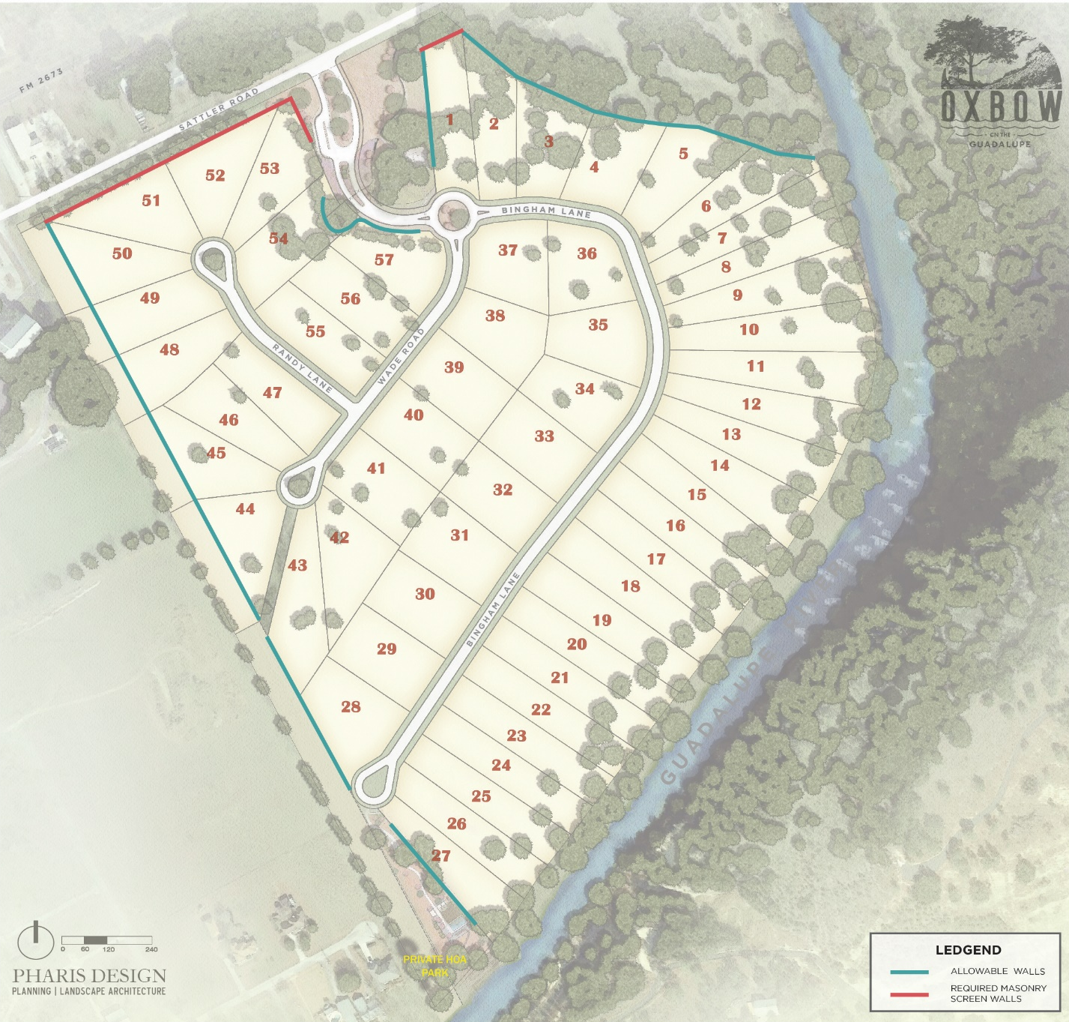

ARTICLE IV
SITE AND LANDSCAPE DESIGN GUIDELINES

- Typical Lot Diagrams

    - Each lot has been designed with a buildable area within which all improvements must occur. Driveways, utility connections, and river access points are notable exceptions.
    - Areas outside the buildable area should remain native, and can be enhanced through the addition of landscaping. Regular mowing of the native area is discouraged.

  - Combining Lots

    - When desired, the combining of two individual lots to create one, large lot may be allowed. Applicants must receive written consent from the Oxbow ACC in order to combine lots.
    - A revised building envelope will be prepared by the ACC with input from owner and their consultants and shall not exceed the sum of the building envelope area of the combined lots.
    - All other restrictions will not be modified.

  - Driveways and Parking

    - Allowable driveway materials include: Concrete, stone pavers, precast concrete pavers, colored or textured concrete, stabilized gravel ( road base) with stone or concrete border. Colored concrete must be integral color and may not include any primary or bright colors. A neutral palette is preferred. Color and finish samples for all driveway materials must be submitted to the ACC for final approval.
    - Prohibited Materials: Un-stabilized gravel, stamped asphalt, bare dirt, grass
    - Vehicular gates on individual driveways/ lots are not permitted.
    - All driveways must include an auto court to accommodate easy turnaround and guest parking. Auto courts shall minimize the visibility of paved areas from adjacent lots, common areas and streets paired with the use of planting/ screening and/or low walls.
    - The minimum driveway width is 10 feet and the maximum driveway width is 15 feet. Driveway width may be wider than 15 feet at driveway aprons to garage entrances, connections to the street and/or where they provide turnaround into an auto court and/or guest parking.

Internal Lot
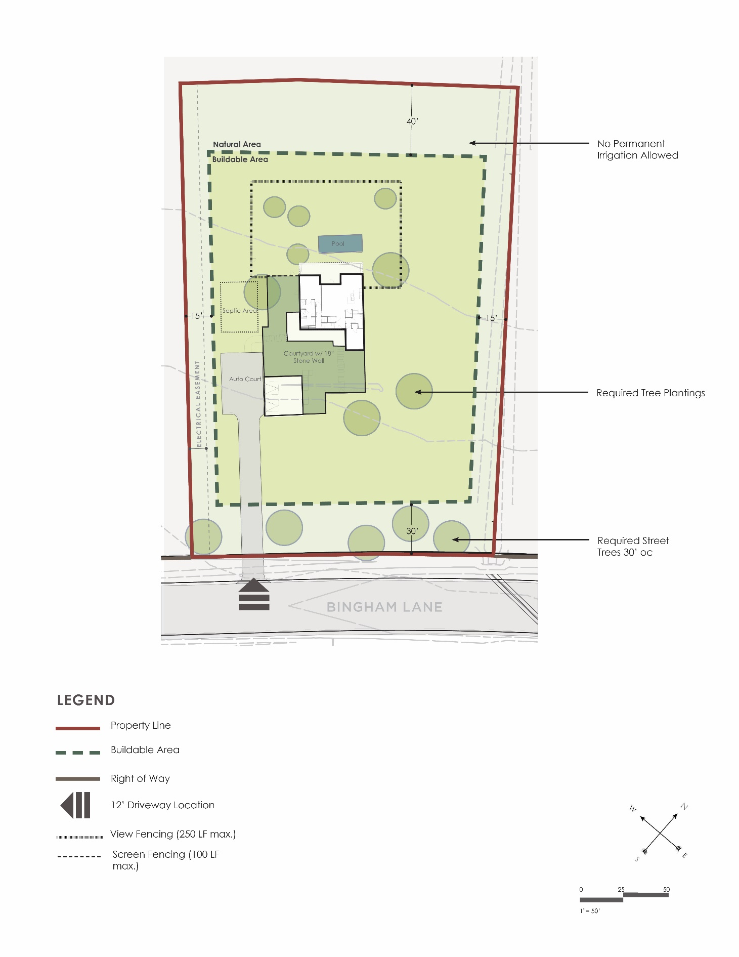

Corner Lot
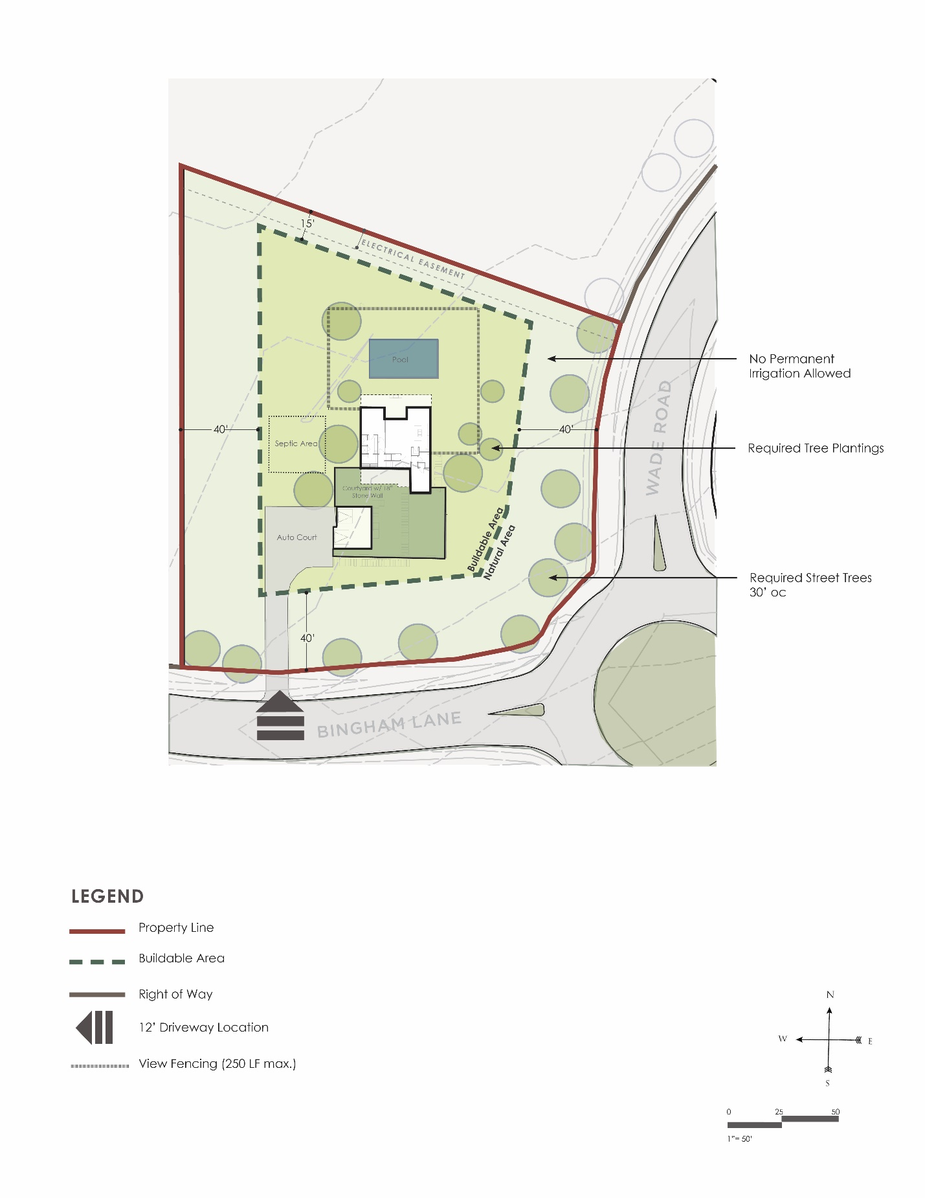

Rear Easement Lot
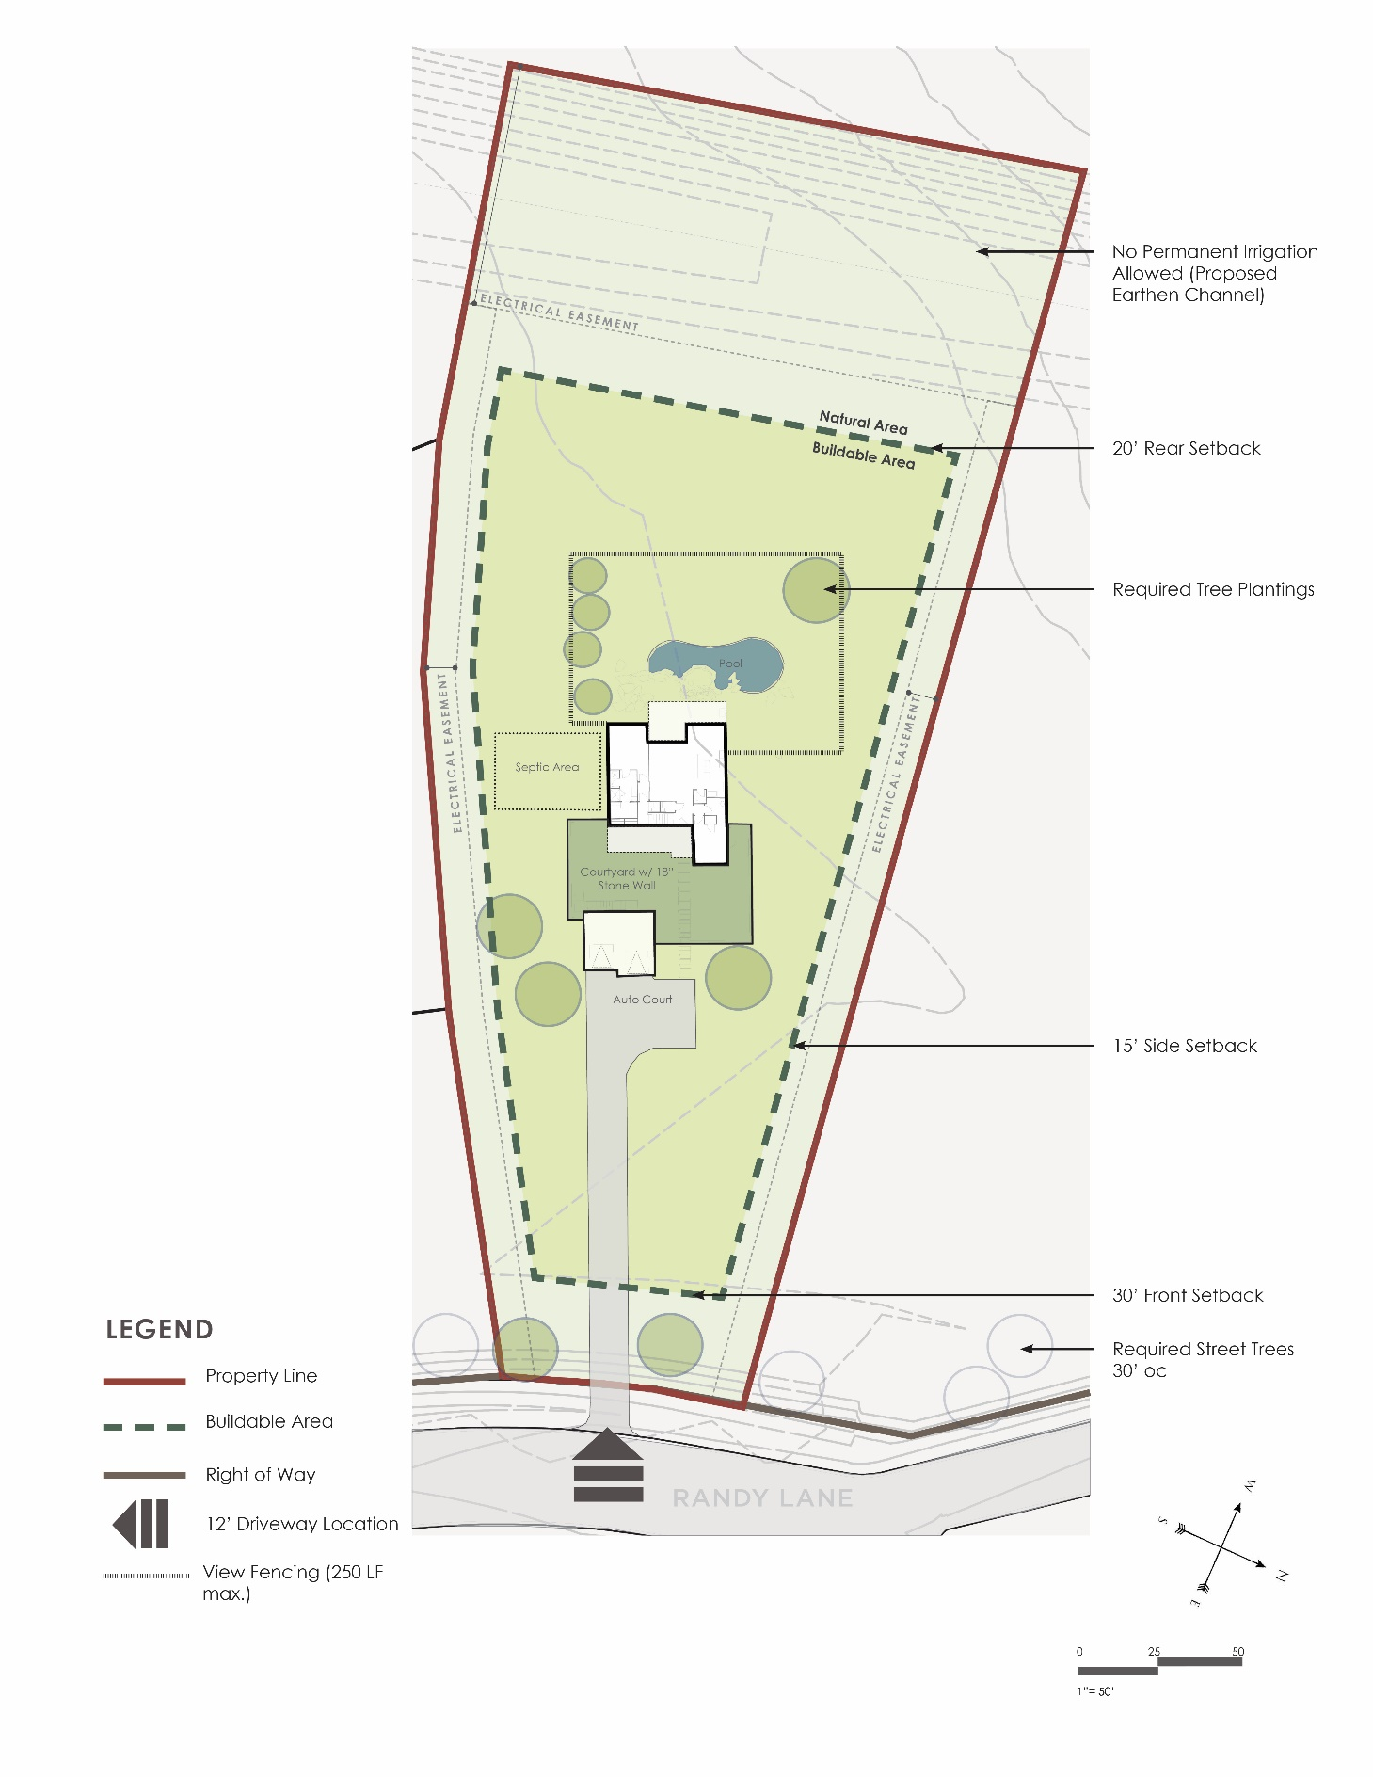

Sattler Road Lot
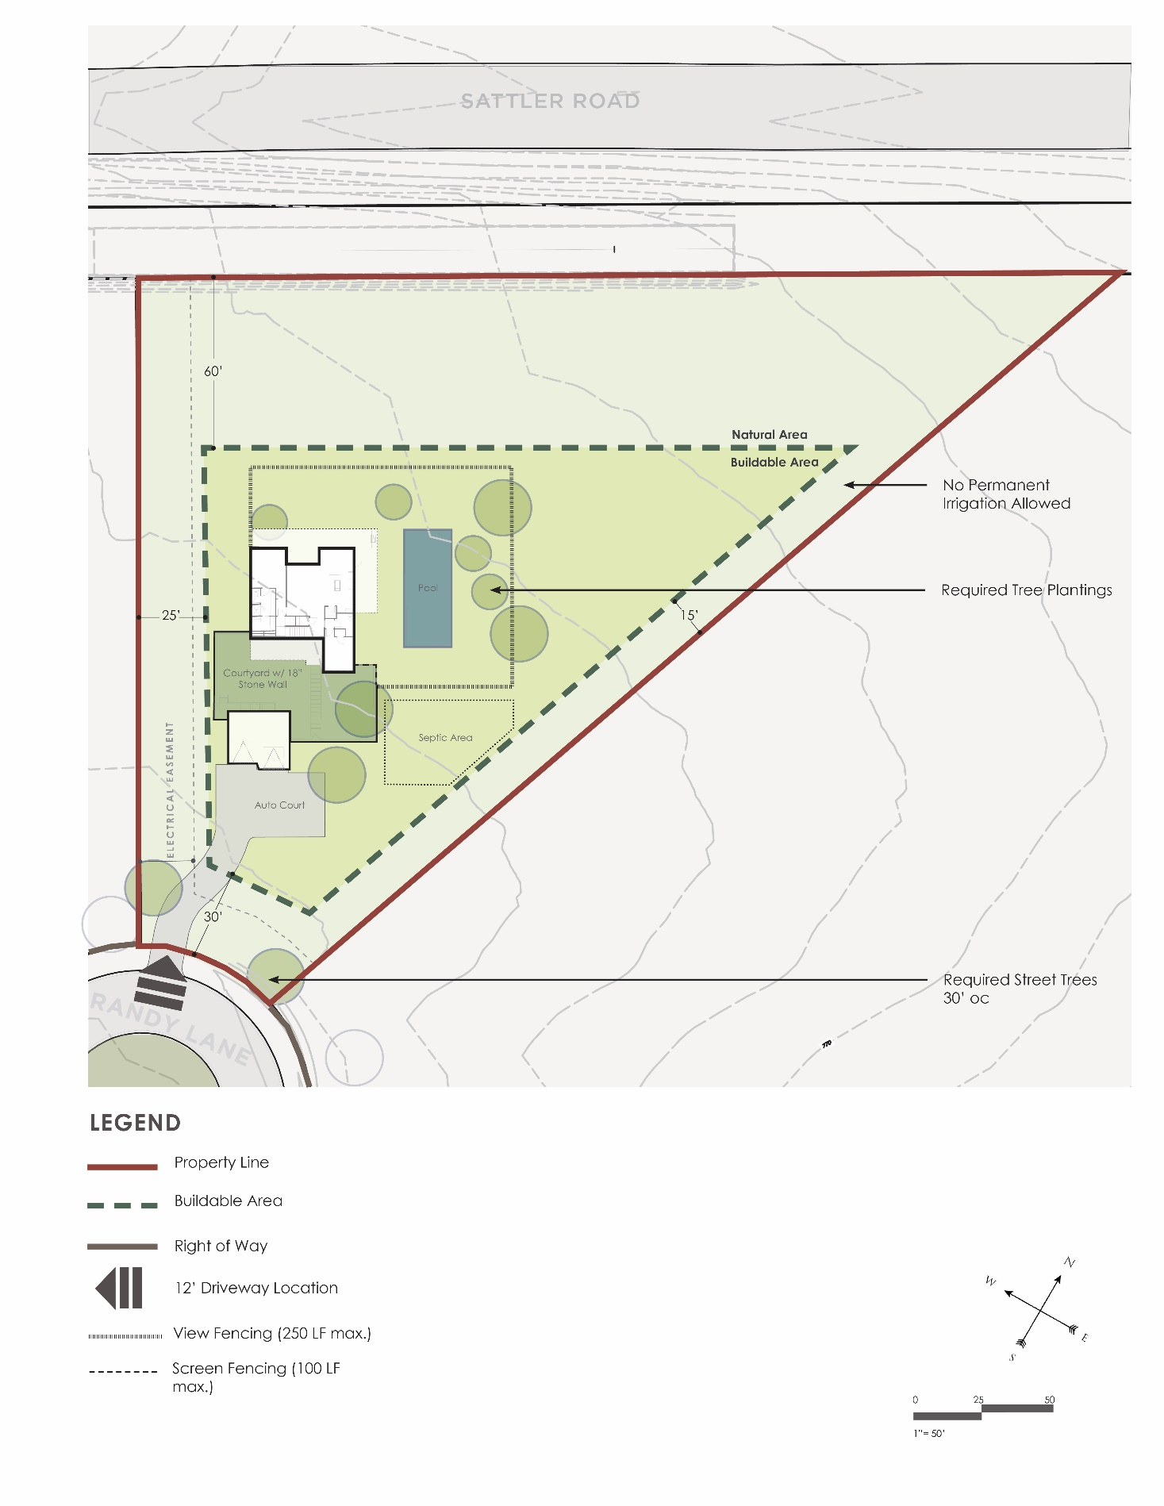

Riverfront Lot
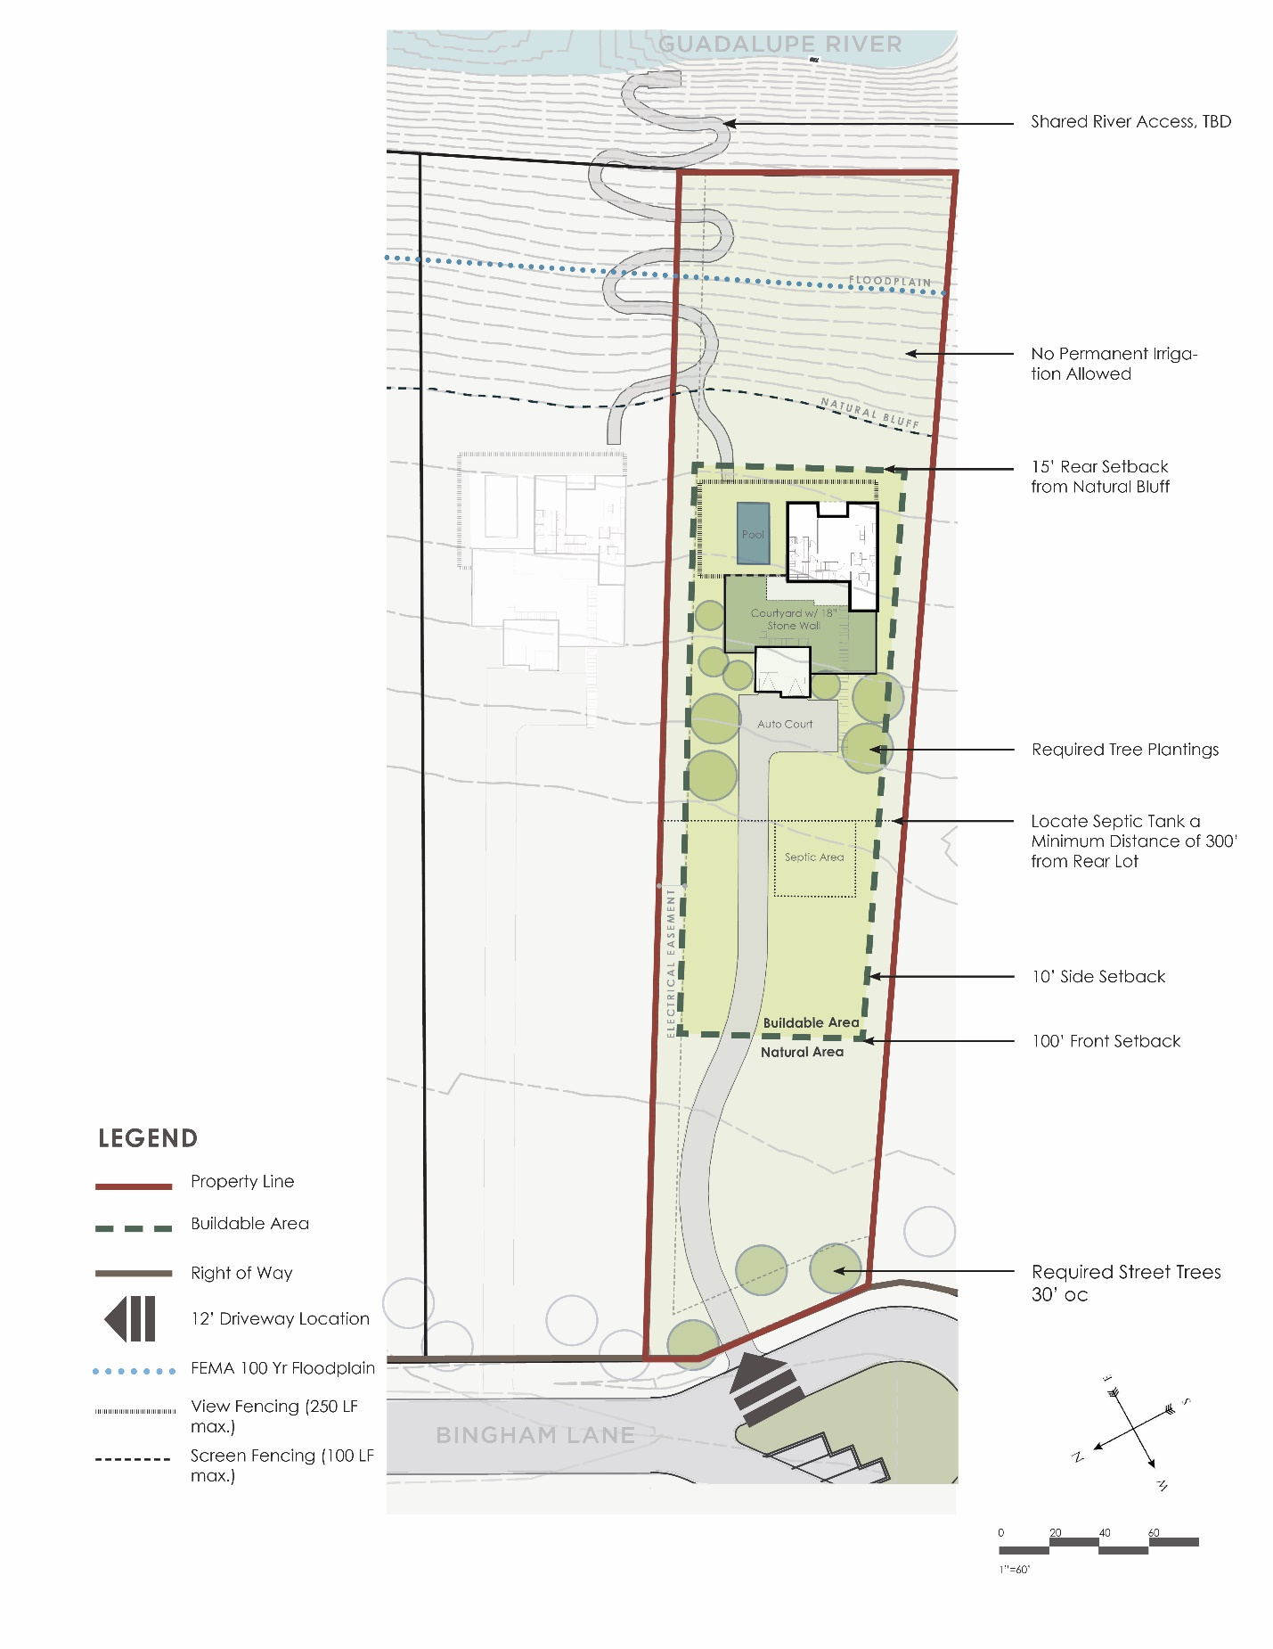

  - Fencing, walls and gates

    - Fences and walls must be located within the buildable area of the lot. Notable exceptions include a masonry wall along Sattler Road.
    - Retaining walls required outside of the building area must obtain approval from the ACC prior to construction.
    - Fencing and walls must be attached to the home (beginning and ending) and may not exceed 250 feet in total length. The intent is for only a small yard/ patio area to be fenced for privacy, pool enclosure, pets, etc. in the rear yard area of the home. Solid, freestanding masonry walls between 3 and 6 feet in height are allowable, but shall be limited to a total of 100 feet in length and should be used in areas where screening is desired. IE side yard views from neighbors.
    - Freestanding fences or walls shall not exceed 6 feet in height.
      - Fencing Diagram

    - No solid wood picket fencing shall be allowed. All fences shall be designed to allow views through the fencing, through picket spacing, etc. The use of ornate finials as picket caps shall not be allowed.

      - Allowable Fencing Types:

      - Non-Allowable Fencing Types:

    - Solid masonry screen walls are allowed along the rear lot line for lots abutting Sattler Road and the western electrical easement. These portions of fencing shall not count towards the allowable 250 linear feet. Refer to overall wall and fence diagram figure 3.5.

      - Allowable Solid Masonry Screen Walls:

    - Retaining walls are limited to 4 feet in height and are encouraged to step with topography.
    - Masonry walls less than 3 feet in height are not subject to fence length or opacity requirements, and must be located within the buildable area.

      - Allowable Short Masonry Wall Types:

    - Fences must be finished in a natural color palette (gray, brown, white, dark green, etc.) and may not include any primary or bright colors. All finishes must be presented to the ACC for review and approval.

  - Culverts and Drainage

    - Layout of driveways shall follow alignments that minimize grading and other disturbance to the site.
    - Driveways must allow for adequate drainage along the street with the use of a culvert.
    - Culverts shall maintain a maximum 3:1 slope at driveway aprons.
    - The visibility of the culvert shall be minimized to the greatest extent feasible.
    - Refer to overall Lot Shell Exhibit figure 3.3 for recommended driveway locations for each lot. Final driveway location shall be provided on the site plan for review and approval by the Oxbow ACC.

  - Landscaping

    - Minimum planting requirements for individual lots:
- 4 Shade trees (Minimum 2” caliper)
- 2 Ornamental Trees (Minimum 30 Gallon)
- A minimum of 250 square feet of Planting beds, which shall include at least the following:
    - 20 (5 Gallon) Shrubs
    - 20 (1 Gallon) Shrubs
- All landscaping and irrigation must be installed prior to occupancy of the home.
    - Plant Material
      - All planting shall utilize native and/or well adapted plant species. Reference the City of Austin Grow Green Guide and/or the Lady Bird Johnson Wildflower Center. See Appendix A for approved and prohibited plant species.
      - Manicured Areas (Those requiring permanent irrigation, regular maintenance and/or mowing) shall be limited to the extents of the buildable area.
      - Planting designs are encouraged to transition and blend into the native landscape and natural areas.

    - Natural Areas
      - Areas outside of the developed, buildable area shall preserve the native existing vegetation to the greatest extent possible.
      - All natural areas damaged during construction must be vegetated to a minimum of what existed before construction.
      - Grading, cut/fill shall be limited in these areas to preserve the natural character.
    - Irrigation
      - A permanent irrigation system shall only be allowed within the buildable area of the lot and shall not be permitted in the natural area of the lot.
      - No more than 30% of the buildable area may be sodded, maintained or irrigated as a grass lawn. St. Augustine and Bermuda Seed grasses are prohibited. Bermuda Hybrid grasses are permitted.
      - An automatic, underground irrigation system is required and must be installed by a licensed irrigation contractor.
      - All irrigation shall be drip type irrigation. Spray irrigation is not allowed.
      - All permanent systems must utilize an automatic, programmable controller and a rain/weather gauge to maximize efficiency.
      - Temporary above ground spray irrigation may be installed in the natural areas to establish native plantings and/or seed, only until plants are established and/or for a maximum of one year.

  - Streetscape Planting Guidelines

    - Each lot is required to install and maintain a minimum of 2 shade trees (minimum 2 inches in caliper).
    - Trees shall be installed within the front setback area and should be spaced an average of 30 feet on center, following an organic alignment (not in a straight line). Refer to Required Streetscape Exhibit 4.7.4 for the approximate location of the required trees.
    - Allowable species for required street trees are:
      - Cedar Elm
      - Burr Oak
      - Live Oak
      - Monterrey (Mexican White) Oak
      - Lacey Oak

    - Required Street Trees
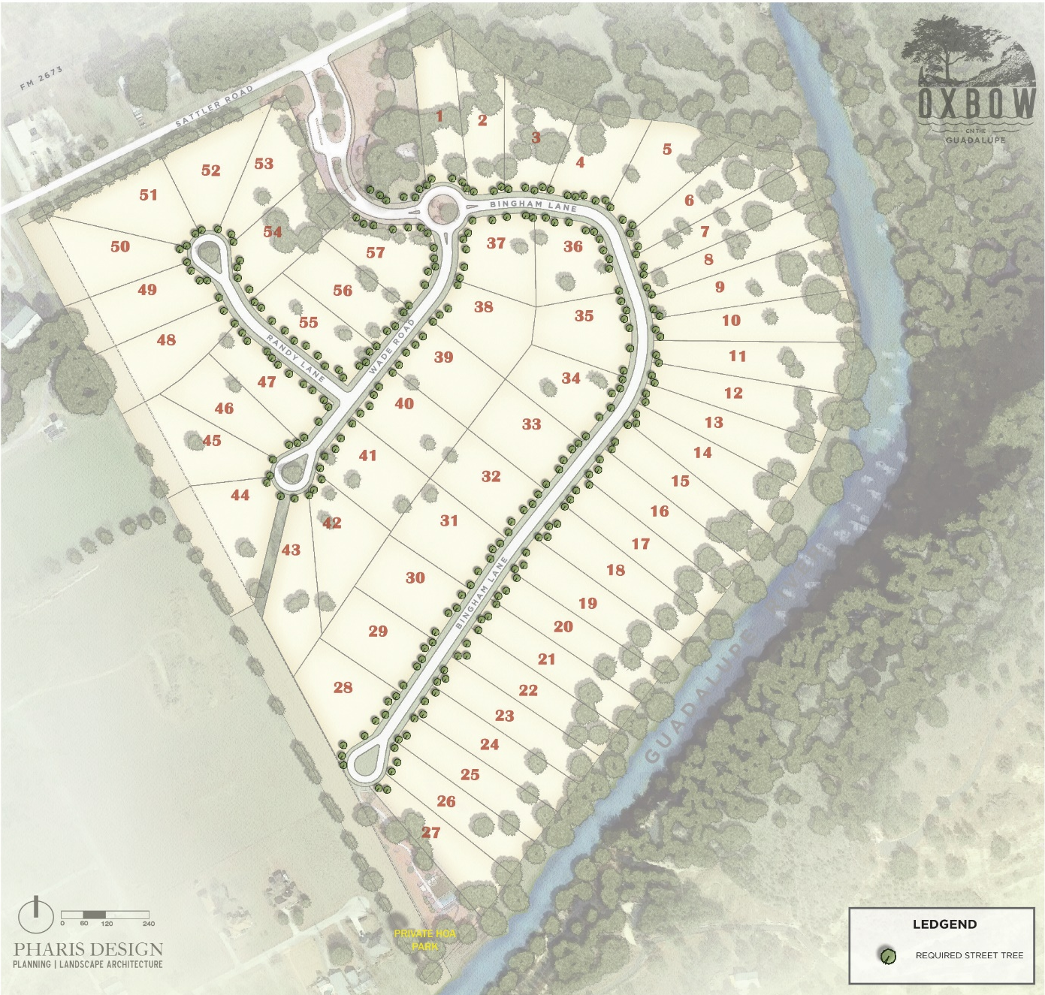

    - Streetscape planting areas shall preserve the existing vegetation of desirable species to greatest extent possible.

  - Legacy Tree Protection

    - Legacy trees shall not be removed unless approved by the ACC.
    - A legacy tree is a tree larger than 26 caliper inches and includes the following species: Oak (any species), Pecan, Cypress, Cedar Elm, Sycamore and Walnut.
    - Homes and improvements shall be designed to protect legacy trees and their root zones.
  - Screening Required

    - Screening of auto court paving, a/c units, pool equipment, utility and gas meters, OSSF equipment, and irrigation equipment, is required.
    - Homes must employ evergreen vegetation as a screening option to the greatest extent possible.
    - Solid masonry walls may be utilized for screening, but are only allowable within the buildable area of the lot and are subject to the overall wall/fence requirements as outlined in Section 4.4. When solid masonry walls are utilized, they must be used in combination with planting material.

  - Sport Courts

    - All exterior recreational or play equipment – swings, slides, play structures, jungle gyms, etc. must be within the buildable envelope
    - Play equipment may not exceed 12 feet in height
    - Must utilize neutral and conservative colors in appearance.
    - Tennis courts and/ or sport courts may not be illuminated, and must be heavily screened from the view of a neighbor and are only allowed to be located within the buildable area of the lot.
    - Plans for recreational facilities must be approved by the ACC and shown on a copy of the approved site plan and must include proposed masonry/vegetative screening.

  - Courtyards / Patios

    - Generally, outdoor rooms that are extensions of the home are encouraged within the Oxbow community.
    - All courtyards and patios shall be built within buildable area of the lot.
    - Should use natural materials such as stone and stone tile, and gravel. Concrete is allowed, but should be colored or textured to compliment residence.
    - Extending floor material from the inside of the home to the outdoor space is encouraged.

  - Lighting

    - The Oxbow community will follow International Dark Sky Community guidelines.
    - When operated, light fixtures must not produce an intense glare or direct illumination across the property line.
    - No strobe lights, up lighting, or distracting flashing lights are allowed.
    - Security lights must be on a motion sensor
    - All exterior light fixtures must be fully shielded.
    - All exterior luminaires shall be directed downward.
    - String lights and lower level, pedestrian scale lights are allowed.
    - Light fixtures shall generally be cohesive with the architecture of the home related to style, finish and color.

  - Pools and Water Features

    - Must be built within the buildable area envelope
    - Swimming pools shall only be in-ground, on balanced cut and fill, and shall be designed to be compatible with the site and dwelling.
    - Pool plans must be approved by the ACC and submitted as part of the site plan, or when being installed after completion of a home, the pool must be drawn on a copy of a previously approved site plan.
    - In general, pools and water features must be designed to be integral parts of outdoor rooms and visually blend with landscape.
    - Mechanical equipment for the pool must be located next to the home, and must not be visible from the street, common areas, adjacent lots/ homes.
    - Pools, gates and enclosures must be constructed in accordance with the regulations of the current international building code, and Comal county regulations, including enclosure height.
    - Above ground hot tubs are allowed, but must be screened and shall not be visible to/ from adjacent lots and homes.

  - River Access

    - A common HOA lot is located to allow river access by residents and guest of the Oxbow community. Any resident without direct ownership of the river frontage is only permitted to access the river in this location.
    - River Access Lots
    - To avoid disturbance and protect views, all river front lots shall share access as identified in the River Access Plan
    - River access steps shall be made of natural materials: boulders, pavers, stepping stones, and incorporate handrails and landings were necessary for safety.
    - Paved pathways made of asphalt or concrete are not permitted.
    - Shall be designed and constructed to minimize site disturbance and preserve existing vegetation.

      - Riverfront Access Plan:

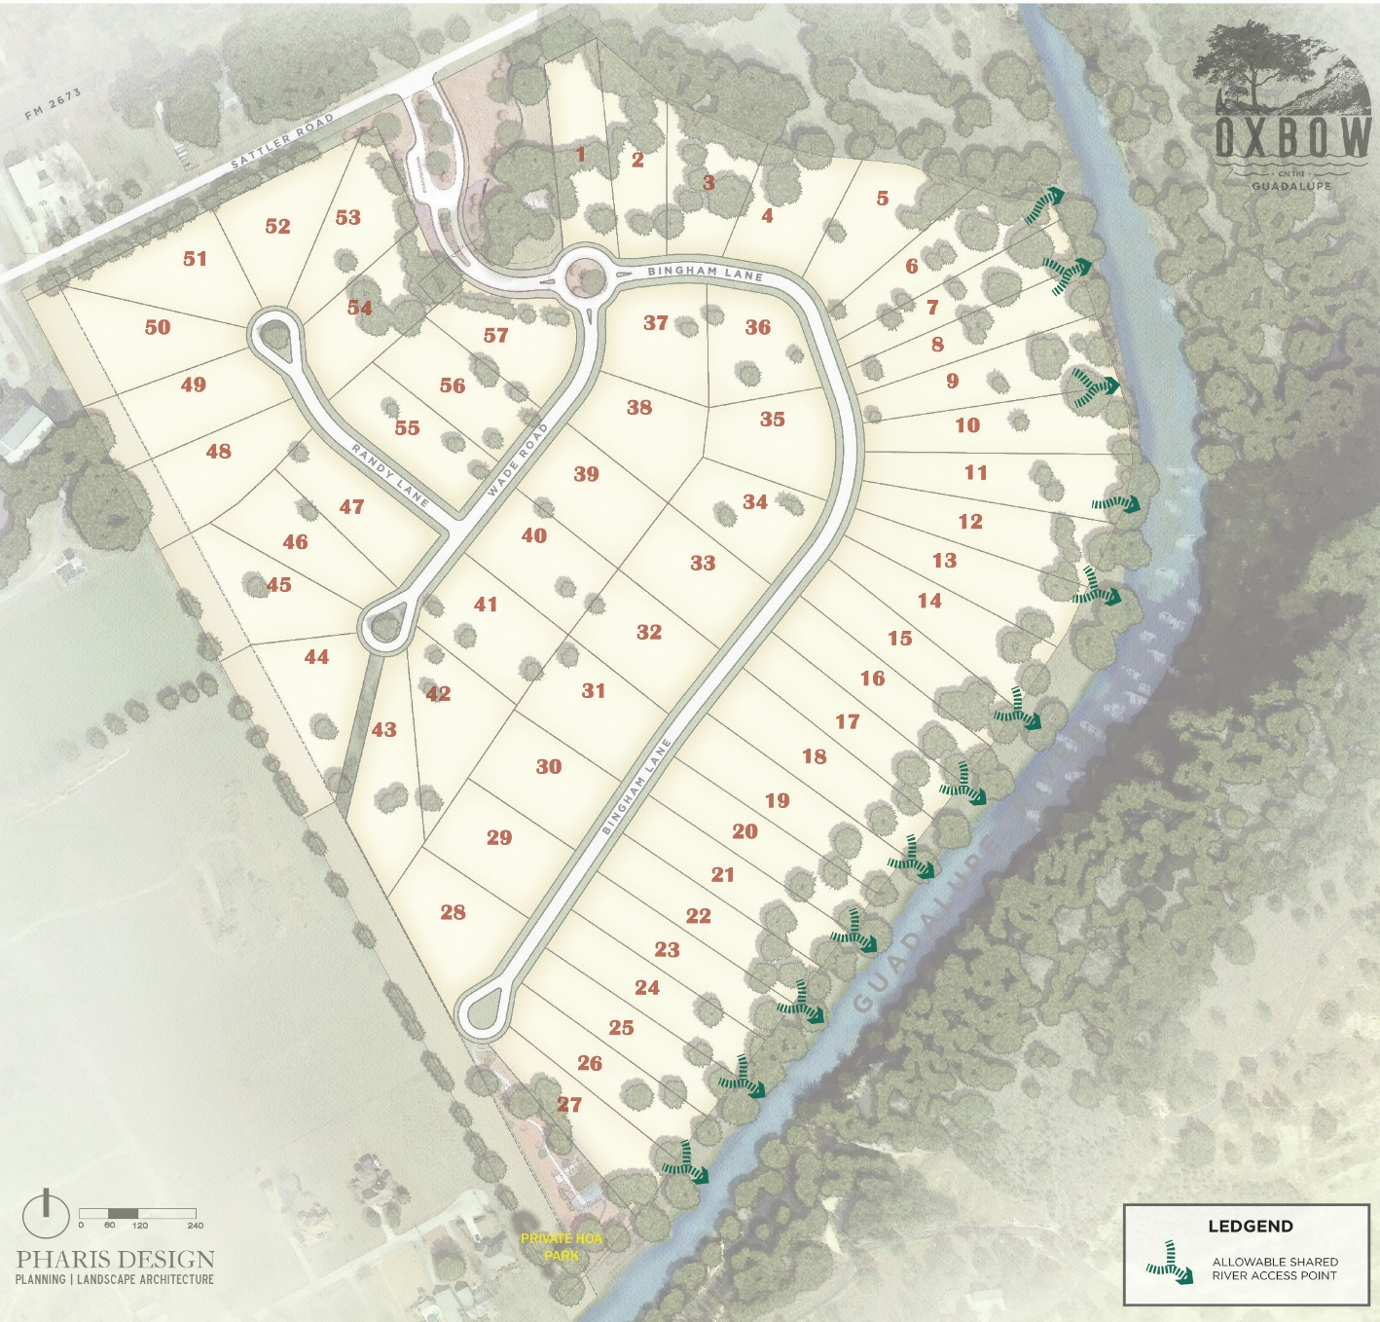

ARTICLE V
ARCHITECTURAL DESIGN GUIDELINES

- Homestyle Character
    - The architectural character of the homes should reflect the regional vernacular Texas and the Hill Country region. Materials should be local, true, and natural to the greatest extent feasible to reduce long term maintenance, and ensure timeless value. Home designs should value outdoor connections, and include spaces that blur the line between indoor and outdoor living.

      - Complying Example images

      - Non-complying Example images

  - Architectural Design Requirements

    - Roof Pitches
      - Roof designs shall incorporate offsets and/or multi level design to avoid the appearance of large, unbroken roof planes. In general, maximum allowable roof pitch is 6:12.
    - Primary Home Size
      - Minimum: 2,200 Square Feet
      - Maximum: 5,000 Square Feet

  - Building Height

    - Single story: no more than 24 feet in height
    - Two story: no more than 32 feet in height.

  - Building Colors

    - Generally, building should be finished in a natural color palette (gray, brown, white, dark green, etc.) and may not include any primary or bright colors. All finishes must be presented to the ACC for review and approval.

  - Building Massing

    - In general, buildings shall be simple volumes, asymmetrical, one or two story masses that respond to the site’s significant features.
    - For home sizes between:
      - 2,200 SF - 3,000 SF the second floor conditioned space shall not exceed 40% of total primary home size;
      - 3,000 SF - 4,000 SF the second floor conditioned space shall not exceed 35% of total primary home size;
      - 4,000 SF - 5,000 SF the second floor conditioned space shall not exceed 30% of total primary home size.
    - Building masses shall respond to the site and natural topography, with stepped foundations, stem walls, etc. when necessary and appropriate.
    - No more than 12” of exposed foundation shall be permitted. Foundations exceeding this requirement must be clad in stone, brick, etc. and shall be cohesive with the overall home design.

  - Primary Building Materials

    - Shall utilize local building materials to the greatest extent feasible. Allowable: Stone, Stucco, Painted Cementous siding, Wood, and metal accents.
    - Vinyl Siding and EIFs are non-allowable building materials.

  - Garages

    - All lots shall include an enclosed garage that can accommodate a minimum of 2 cars.
    - Garages must be sited and located so that visibility from any street is minimized.
    - In situations where a 3 or more car garage is desired, the 3rd garage must be separate in form and mass.
    - Side entry garages are strongly encouraged
    - Garage doors which face streets or common areas must be set an additional 5 feet back from the building front facade.
    - Garage panels shall be complementary in color, material and design to the primary home.

  - Accessory Structures

    - Outdoor storage buildings, unless designed by an architect and submitted for review by the ACC shall not be permitted.
    - Other accessory structures (guest houses, servant’s quarters, in law apartments, etc.) are permissible and shall be submitted as per these Design Guidelines and approved by the ACC and Comal County prior to construction.
    - Accessory structures shall not exceed 1,000 square feet and must occur entirely within the buildable portion of the lot.
    - In instances of combined lots, one accessory structure shall be allowed, occurring entirely within the buildable portion of the lot.

ARTICLE VI
GENERAL STANDARDS

6.1 Garages. All garages, carports and other open automobile storage units shall be approved in advance of construction by the Board. No garage may be permanently enclosed or otherwise used for habitation. The garage requirements for each residence are set forth in the Design Guidelines.

6.2 Fences. No fence may be constructed on the Property without the prior written consent of the Board. If adopted, all fences must strictly comply with the requirements of the Design Guidelines unless a variance is obtained pursuant to the Restrictions. The fencing requirements for each residence constructed on a Lot are set forth in the Design Guidelines.

6.3 Driveways. The design, construction material, and location of: (i) all driveways, and (ii) culverts incorporated into driveways for ditch or drainage crossings, must be approved by the Board and be in conformance with the Plat and drainage design for the Property. Each Owner will be responsible, at such Owner’s sole cost and expense, for properly and on a timely basis (both standards to be determined by the Board in the Board’s sole and absolute discretion) maintaining and repairing the driveway on such Owner’s Lot. Each Owner will be required to construct a driveway with a culvert as determined by the drainage design for the Property. Additional driveway requirements may be set forth in the Design Guidelines.

6.4 Roofing. All roofing material shall be approved in advance of construction by the Board. In addition, roofs of buildings may be constructed with “Energy Efficiency Roofing” with the advance written approval of the Board. For the purpose of this Section, “Energy Efficiency Roofing” means shingles that are designed primarily to: (a) be wind and hail resistant; (b) provide heating and cooling efficiencies greater than those provided by customary composite shingles; or (c) provide solar generation capabilities. The Board will not prohibit an Owner from installing Energy Efficient Roofing provided that the Energy Efficient Roofing shingles: (i) resemble the shingles used or otherwise authorized for use within the Property; (ii) are more durable than, and are of equal or superior quality to, the shingles used or otherwise authorized for use within the community; and (iii) match the aesthetics of adjacent property. An Owner who desires to install Energy Efficient Roofing will be required to comply with the architectural review and approval procedures set forth in the Restrictions. In conjunction with any such approval process, the Owner should submit information which will enable the Board to confirm the criteria set forth in this Section. Any other type of roofing material shall be permitted only with the advance written approval of the Board.

6.5 Air Conditioning Units; No Window AC Units. Air conditioning units shall be screened from visibility from any street by appropriate landscaping or fencing. No window or wall type air conditioner that is visible from any street or any other Improvement shall be permitted to be used, placed or maintained on or in any structure on any part of the Property. Window air conditioners are prohibited.

6.6 HVAC Location. No air-conditioning apparatus may be installed on the ground in front of a residence or on the roof of any residence, unless otherwise approved in advance by the Board. No air-conditioning apparatus or evaporative cooler may be attached to any front wall or front window of a residence or at any other location where it would be visible from any street, any other residence, Common Area, unless otherwise approved in advance by the Board. All HVAC units must be screened in a manner approved in advance by the Board, or as otherwise set forth in the Design Guidelines.

6.7 Barbecue Units. Barbecue units are only permitted within the rear yard of each Lot in and placed in such manner as to be reasonably screened from any other portion of the Development, if possible. The “rear yard” for the purpose of this provision means the yard area in the rear or posterior to the residence constructed on a Lot including, without limitations, rear porches, patios, or decks. In the event of any dispute regarding what portion of a Lot constitutes the “rear yard” the opinion of the Board will be final, binding, and conclusive.

6.8 Clotheslines; Awnings. No clotheslines and no outdoor clothes drying or hanging shall be permitted in the Development, nor shall anything be hung, painted or displayed on the outside of the windows (or inside, if visible from the outside) or placed on the outside walls or outside surfaces of doors of or any residence on any Lot, and no awnings, canopies or shutters (except for those heretofore or hereinafter installed in accordance with Plans and Specifications approved by the ACC) shall be affixed or placed upon the exterior walls or roofs of any residence on any Lot, or any part thereof, nor relocated or extended, without the prior written consent of the ACC.

6.9 Basketball Goals. Permanent basketball goals are permitted on a Lot provided that the basketball goal location and all materials are approved in advance and in writing by the ACC. Portable basketball goals are permitted, provided that: (i) no portable basketball goal may be placed or utilized on or within any right-of-way; and (ii) the basketball goal location must be approved by the ACC. All basketball goals must be properly maintained and painted, with the net in good repair. In the event that an Owner fails to comply with the provisions of this Section, the ACC, or its agent shall have the express authority to remove the offending Improvements, the expense of which shall be borne by the Owner thereof.

6.10 Wind Energy Generation Equipment. No windmills, wind generators or other apparatus for generating power from wind shall be erected or installed on any Lot.

6.11 Tennis Courts, Recreational Courts and Playscapes. Tennis courts, playscapes, recreational, e.g., “sport courts” or any similar recreational facilities may not be constructed on any Lot without the advance written approval of the Board. The Board may prohibit the installation of tennis courts, recreational courts, playscapes or similar recreational facilities on any Lot.

6.12 Decorations and Lighting. Unless otherwise permitted by the ACC, no decorative appurtenances such as sculptures, birdbaths and birdhouses, fountains, or other decorative embellishments shall be placed on the residence or on the front yard or on any other portion of a Lot which is visible from any street, unless such specific items have been approved in writing by the ACC. Customary seasonal decorations for holidays are permitted without approval by the ACC but shall be removed within thirty (30) days of the applicable holiday. Outside lighting fixtures shall be placed so as to illuminate only the yard of the applicable Lot and so as not to affect or reflect into surrounding residences or yards. No mercury vapor, sodium or halogen light shall be installed on any Lot which is visible from any street unless otherwise approved by the ACC.

6.13 Mobile Homes, Travel Trailers and Recreational Vehicles. No mobile homes, travel trailers or recreational vehicles shall be parked or placed on any street, right of way, Lot (except pursuant to an approved covered structure) or used as a residence, either temporary or permanent, at any time. However, such vehicles may be parked temporarily for a period not to exceed seventy-two (72) consecutive hours during each two (2) month period. Mobile homes, travel trailers or recreational vehicles may be stored on a Lot in a garage or covered structure approved in advance by the ACC.

6.14 Tanks. The ACC must approve any tank used or proposed in connection with a residence, including tanks for storage of fuel, water, oil, or liquid petroleum gas (LPG). No elevated tanks of any kind may be erected, placed or permitted on any Lot within the Property. All permitted tanks must be buried. This provision will not apply to a tank used to operate a standard residential gas grills, nor shall it apply to air conditioning compressors or swimming pool filter tanks (which must be screened from view if visible from any street in accordance with a screening plan approved in advance by the ACC), or barrels used as part of a Rainwater Harvesting Systems with a capacity of less than 50 gallons, so long as such barrels are actively being used for rainwater collection and storage.

6.15 Temporary Structures. No tent, shack, or other temporary building, Improvement, or structure shall be placed upon the Property without the prior written approval of the ACC; provided, however, that temporary structures necessary for storage of tools and equipment, and for office space for Homebuilders, architects, and foremen during actual construction may be maintained with the prior approval of the Declarant, approval to include the nature, size, duration, and location of such structure.

6.16 Signs. Unless otherwise prohibited by Applicable Law, no sign of any kind may be displayed to the public view on any Lot without the prior written approval of the ACC, except for:

    - Declarant Signs. Signs erected by the Declarant or erected with the advance written consent of the Declarant;

    - Security Signs. One small security service sign per Lot, provided that the sign has a maximum face area of two (2) square feet and is located no more than five (5) feet from the front elevation of the principal residence constructed upon the Lot;

    - Permits. Permits as may be required by Applicable Law;

    - Religious Item on Door. A religious item on the entry door or door frame of a residence (which may not extend beyond the outer edge of the door frame), provided that the size of the item(s), individually or in combination with other religious items on the entry door or door frame of the residence, does not exceed twenty-five (25) square inches;

    - Sale or Rental Signs. One (1) temporary “For Sale” or “For Lease” sign per Lot, provided that the sign shall be limited to: (i) a maximum face area of five (5) square feet on each visible side and, if free standing, is mounted on a single or frame post; (ii) an overall height of the sign from finished grade at the spot where the sign is located may not exceed four feet (4’); and (iii) the sign shall be removed within two (2) business days following the sale or lease of the Lot;

    - Political Signs. Political signs may be erected provided the sign: (i) is erected no earlier than the 90th day before the date of the election to which the sign relates; (ii) is removed no later than the 10th day after the date of the election to which the sign relates; and (iii) is ground-mounted. Only one sign may be erected for each candidate or ballot item. In addition, signs which include any of the components or characteristics described in Section 202.009(c) of the Texas Property Code are prohibited; and

    - No Soliciting: Signs. A “no soliciting” sign near or on the front door to the principal residence constructed upon the Lot, provided, that the sign may not exceed twenty-five (25) square inches.

Except for signs which are erected by the Declarant or erected with the advance written consent of the Declarant, no sign may be displayed in the window of any Improvement located on a Lot.

6.17 Flags. Owners are permitted to display certain flags on the Owner’s Lot, as further set forth below.

(a) Approval Requirements. An Owner is permitted to display the flag of the United States of America, the flag of the State of Texas, an official or replica flag of any branch of the United States Military, or one (1) flag with official insignia of a college or university (“Permitted Flag”) and permitted to install a flagpole no more than five feet (5’) in length affixed to the front of a residence near the principal entry or affixed to the rear of a residence (“Permitted Flagpole”). Only two (2) permitted Flagpoles are allowed per residence. A Permitted Flag or Permitted Flagpole need not be approved in advance by the ACC. Approval by the ACC is required prior to installing vertical freestanding flagpoles installed in the front or back yard area of any Lot (“Freestanding Flagpole”). Freestanding flagpoles are not allowed in the front yard of any Lot. To obtain ACC approval of any Freestanding Flagpole, the Owner shall provide the ACC with the following information: (a) the location of the Freestanding Flagpole to be installed on the Lot; (b) the type of Freestanding Flagpole to be installed; (c) the dimensions of the Freestanding Flagpole; and (d) the proposed materials of the Freestanding Flagpole (the “Flagpole Application”). A Flagpole Application may only be submitted by an Owner.

    - Flags - Installation and Display. Unless otherwise approved in advance and in writing by the Board, Permitted Flags, Permitted Flagpoles and Freestanding Flagpoles, installed in accordance with the Flagpole Application, shall comply with the following:

      - No more than one (1) Freestanding Flagpole OR no more than two (2) Permitted Flagpoles are permitted per Lot, on which only Permitted Flags may be displayed;

      - Any Permitted Flagpole shall be no longer than five feet (5’) in length and any Freestanding Flagpole shall be no more than twenty feet (20’) in height;

      - Any Permitted Flag displayed on any flagpole may not be more than three feet in height by five feet in width (3’ x 5’);

      - With the exception of flags displayed on Common Area and any Lot which is being used for marketing purposes by Declarant or a Homebuilder, the flag of the United States of America shall be displayed in accordance with 4 U.S.C. Sections 5-10 and the flag of the State of Texas shall be displayed in accordance with Chapter 3100 of the Texas Government Code;

      - The display of a flag, or the location and construction of the flagpole shall comply with Applicable Law, easements and setbacks of Record;

      - Any Permitted Flagpole and Freestanding Flagpole must be constructed of permanent, long-lasting materials, with a finish appropriate to the materials used in the construction of the flagpole and harmonious with the residence;

      - A Permitted Flag, Permitted Flagpole or Freestanding Flagpole must be maintained in good condition and any deteriorated flag or deteriorated or structurally unsafe Permitted Flag, Permitted Flagpole or Freestanding Flagpole shall be repaired, replaced or removed;

      - Any Permitted Flag may be illuminated by no more than one (1) halogen landscaping light of low beam intensity, as determined by the ACC in its discretion, which shall not be aimed towards or directly affect any neighboring Lot; and

      - Any external halyard of a Permitted Flagpole or Freestanding Flagpole shall be secured so as to reduce or eliminate noise from flapping against the metal of the Permitted Flagpole or Freestanding Flagpole.

6.18 Solar Energy Device. Solar Energy Devices may be installed with the advance written approval of the Declarant, or after expiration of termination of the Development Period the ACC, in accordance with the procedures and requirements set forth below:

    - Application. To obtain approval of a Solar Energy Device, the Owner shall provide the Declarant or ACC with the following information: (i) the proposed installation location of the Solar Energy Device; and (ii) a description of the Solar Energy Device, including the dimensions, manufacturer, and photograph or other accurate depiction (the “Solar Application”). A Solar Application may only be submitted by an Owner.

    - Approval Process. The Declarant or ACC shall review the Solar Application in accordance with the terms and provisions of this Declaration. The Declarant or ACC shall approve a Solar Energy Device if the Solar Application complies with Subsection (c) below UNLESS the Declarant or ACC makes a written determination that placement of the Solar Energy Device, despite compliance with Subsection (c) below, shall create a condition that substantially interferes with the use and enjoyment of property within the Property by causing unreasonable discomfort or annoyance to persons of ordinary sensibilities. The Declarant or ACC’s right to make a written determination in accordance with the foregoing sentence is negated if all Owners of Lots immediately adjacent to the Owner/applicant provide written approval of the proposed placement. Any proposal to install a Solar Energy Device on property owned or maintained by the Association or property owned in common by Members of the Association must be approved in advance and in writing by the Board, and the Board need not adhere to this policy when considering any such request.

    - Approval Conditions. Unless otherwise approved in advance and in writing by the Declarant or ACC, each Solar Application and each Solar Energy Device to be installed in accordance therewith shall comply with the following:

      - The Solar Energy Device shall be located on the roof of the residence located on the Owner’s Lot, entirely within a fenced area of the Owner’s Lot, or entirely within a fenced patio located on the Owner’s Lot. If the Solar Energy Device shall be located on the roof of the residence, the Declarant or ACC may designate the location for placement unless the location proposed by the Owner increases the estimated annual energy production of the Solar Energy Device, as determined by using a publicly available modeling tool provided by the National Renewable Energy Laboratory, by more than ten percent (10%) percent above the energy production of the Solar Energy Device if installed in the location designated by the Declarant or ACC. If the Owner desires to contest the alternate location proposed by the Declarant or ACC, the Owner should submit information to the Declarant or ACC which demonstrates that the Owner’s proposed location meets the foregoing criteria. If the Solar Energy Device shall be located in the fenced area of the Owner’s Lot or patio, no portion of the Solar Energy Device may extend above the fence line.

      - If the Solar Energy Device is mounted on the roof of the principal residence located on the Owner’s Lot, then: (A) the Solar Energy Device may not extend higher than or beyond the roofline; (B) the Solar Energy Device shall conform to the slope of the roof and the top edge of the Solar Device shall be parallel to the roofline; (C) the frame, support brackets, or visible piping or wiring associated with the Solar Energy Device shall be silver, bronze or black.

6.19 Rainwater Harvesting Systems. Rainwater Harvesting Systems may be installed with the advance written approval of the ACC.

    - Application. To obtain Declarant or ACC approval of a Rainwater Harvesting System, the Owner shall provide the Declarant or ACC with the following information: (i) the proposed installation location of the Rainwater Harvesting System; and (ii) a description of the Rainwater Harvesting System, including the color, dimensions, manufacturer, and photograph or other accurate depiction (the “Rain System Application”). A Rain System Application may only be submitted by an Owner.

    - Approval Process. The decision of the Declarant or ACC shall be made in accordance with this Declaration. Any proposal to install a Rainwater Harvesting System on property owned by the Association or property owned in common by Members of the Association must be approved in advance and in writing by the Declarant or ACC, and the Declarant or ACC need not adhere to this policy when considering any such request.

    - Approval Conditions. Unless otherwise approved in advance and in writing by the Declarant or ACC, each Rain System Application and each Rainwater Harvesting System to be installed in accordance therewith shall comply with the following:

      - The Rainwater Harvesting System shall be consistent with the color scheme of the residence constructed on the Owner’s Lot, as reasonably determined by the Declarant or ACC.

      - The Rainwater Harvesting System does not include any language or other content that is not typically displayed on such a device.

      - The Rainwater Harvesting System is in no event located between the front of the residence constructed on the Owner’s Lot and any adjoining or adjacent street.

      - There is sufficient area on the Owner’s Lot to install the Rainwater Harvesting System, as reasonably determined by the Declarant or ACC.

    - Guidelines. If the Rainwater Harvesting System is installed on or within the side yard of a Lot, or would otherwise be visible from a street, the Common Area, or another Owner’s Lot, the Declarant or ACC may regulate the size, type, shielding of, and materials used in the construction of the Rainwater Harvesting System. Accordingly, when submitting a Rain System Application, such application should describe methods proposed by the Owner to shield the Rainwater Harvesting System from the view of any street, Common Area, or another Owner’s Lot. When reviewing a Rain System Application for a Rainwater Harvesting System that shall be installed on or within the side yard of a Lot, or would otherwise be visible from a street, the Common Area, or another Owner’s Lot, any additional requirements imposed by the Declarant or ACC to regulate the size, type, shielding of, and materials used in the construction of the Rainwater Harvesting System, may not prohibit the economic installation of the Rainwater Harvesting System, as reasonably determined by the Declarant or ACC.

6.20 Native and Well Adapted Species. As part of the installation and maintenance of landscaping on an Owner’s Lot, an Owner may submit plans for and install drought tolerant landscaping upon written approval by the ACC. All Owners implementing drought tolerant landscapes shall comply with the following:

    - Application. Approval by the ACC is required prior to installing Xeriscaping. To obtain the approval of the ACC for Xeriscaping, the Owner shall provide ACC with the following information: (i) the proposed site location of the Xeriscaping on the Owner’s Lot; (ii) a description of the Xeriscaping, including the types of plants, border materials, hardscape materials and photograph or other accurate depiction and (iii) the percentage of yard to be covered with gravel, rocks and cacti (the “Xeriscaping Application”). A Xeriscaping Application may only be submitted by an Owner unless the Owner’s tenant provides written confirmation at the time of submission that the Owner consents to the Xeriscaping Application. The ACC is not responsible for: (i) errors or omissions in the Xeriscaping Application submitted to the ACC for approval; (ii) supervising installation or construction to confirm compliance with an approved Xeriscaping Application or (iii) the compliance of an approved application with Applicable Law.

    - Approval Conditions. Unless otherwise approved in advance and in writing by the ACC each Xeriscaping Application and all Xeriscaping to be installed in accordance therewith shall comply with the following:

      - The Xeriscaping shall be aesthetically compatible with other landscaping in the community as reasonably determined by the ACC. For purposes of this Section, “aesthetically compatible” shall mean overall and long-term aesthetic compatibility within the community. For example, an Owner’s Lot plan may be denied if the ACC determines that: (A) the proposed Xeriscaping would not be harmonious with already established turf and landscaping in the overall community; and/or (B) the use of specific turf or plant materials would result in damage to or cause deterioration of the turf or landscaping of an adjacent property owner, resulting in a reduction of aesthetic appeal of the adjacent property Owner’s Lot.

      - No Owner shall install gravel, rocks or cacti that in the aggregate encompass over ten percent (10%) of such Owner’s front yard or ten percent (10%) of such Owner’s back yard.

      - The Xeriscaping shall not attract diseases and insects that are harmful to the existing landscaping on neighboring Lots, as reasonably determined by the ACC.

    - Process. The decision of the ACC shall be made within a reasonable time, or within the time period otherwise required by the specific provisions in the Design Guidelines, if adopted, or other provisions in the Restrictions that govern the review and approval of improvements. A Xeriscaping Application submitted to install Xeriscaping on property owned by the Association or property owned in common by Members of the Association shall not be approved. Any proposal to install Xeriscaping on property owned by the Association or property owned in common by Members of the Association must be approved in advance and in writing by the Board, and the Board need not adhere to the requirements set forth in this Section when considering any such request.

    - Approval. Each Owner is advised that if the Xeriscaping Application is approved by the ACC, installation of the Xeriscaping shall: (i) strictly comply with the Xeriscaping Application; (ii) commence within thirty (30) days of approval; and (iii) be diligently prosecuted to completion. If the Owner fails to cause the Xeriscaping to be installed in accordance with the approved Xeriscaping Application, the ACC may require the Owner to: (i) modify the Xeriscaping Application to accurately reflect the Xeriscaping installed on the property; or (ii) remove the Xeriscaping and reinstall the Xeriscaping in accordance with the approved Xeriscaping Application. Failure to install Xeriscaping in accordance with the approved Xeriscaping Application or an Owner’s failure to comply with the post-approval requirements constitutes a violation of this Declaration and may subject the Owner to fines and penalties. Any requirement imposed by the ACC to resubmit a Xeriscaping Application or remove and relocate Xeriscaping in accordance with the approved Xeriscaping Application shall be at the Owner’s sole cost and expense.

6.21 Generators. Approval by the ACC is required prior to installing a Generator. To obtain the approval of the ACC for a Generator, the Owner shall provide the ACC with the following information: (i) the proposed site location of the Generator on the Owner’s Lot; (ii) a description of the Generator, including a photograph or other accurate depiction; and (iii) the size of the Generator (the “Generator Application”). A Generator Application may only be submitted by a tenant if the Owner’s tenant provides written confirmation at the time of submission that the Owner consents to the Generator Application. The ACC is not responsible for: (i) errors or omissions in the Generator Application submitted to the ACC for approval; (ii) supervising installation or construction to confirm compliance with an approved Generator Application or (iii) the compliance of an approved application with Applicable Law.

    - Approval Conditions. Each Generator Application and all Generators to be installed in accordance therewith must comply with the following:

      - The Owner must install and maintain the Generator in accordance with the manufacturer's specifications and meet all applicable governmental health, safety, electrical, and building codes.

      - The Owner must use a licensed contractor(s) to install all electrical, plumbing, and fuel line connections and all electrical connections must be installed in accordance with all applicable governmental health, safety, electrical, and building codes.

      - The Owner must install all natural gas, diesel fuel, biodiesel fuel, and/or hydrogen fuel line connections in accordance with applicable governmental health, safety, electrical, and building codes.

      - The Owner must install all liquefied petroleum gas fuel line connections in accordance with the rules and standards promulgated and adopted by the Railroad Commission of Texas and other applicable governmental health, safety, electrical, and building codes.

      - The Owner must install and maintain all non-integral standby Generator fuel tanks in compliance with applicable municipal zoning ordinances and governmental health, safety, electrical, and building codes.

      - The Owner must maintain in good condition the Generator and its electrical lines and fuel lines. The Owner is responsible to repair, replace, or remove any deteriorated or unsafe component of a Generator, including electrical and fuel lines.

      - The Owner must screen a Generator if it is visible from the street faced by the residence, located in an unfenced side or rear yard of a Lot, and is visible either from an adjoining residence or from adjoining property owned by the Association, and/or is located in a side or rear yard fenced by a wrought iron or residential aluminum fence and is visible through the fence either from an adjoining residence or from adjoining property owned by the Association.

      - The Owner may only perform periodic testing of the Generator consistent with the manufacturer’s recommendations between the hours of 9 a.m. to 5 p.m., Monday through Friday.

      - No Owner shall use the Generator to generate all or substantially all of the electric power to the Owner's residence unless the utility-generated electrical power to the residence is not available or is intermittent due to causes other than nonpayment for utility service to the residence.

      - No Owner shall locate the Generator (i) in the front yard of a residence; or (ii) in the side yard of a residence facing a street.

      - No Owner shall locate a Generator on property owned by the Association.

      - No Owner shall locate a Generator on any property owned in common by Members of the Association.

    - Process. Any proposal to install a Generator on property owned by the Association or property owned in common by Members of the Association must be approved in advance and in writing by the Board, and the Board need not adhere to the requirements set forth in this Generator Policy when considering any such request.

    - Approval. Each Owner is advised that if the Generator Application is approved by the ACC, installation of the Generator must: (i) strictly comply with the Generator Application; (ii) commence within thirty (30) days of approval; and (iii) be diligently prosecuted to completion. If the Owner fails to cause the Generator to be installed in accordance with the approved Generator Application, the ACC may require the Owner to: (a) modify the Generator Application to accurately reflect the Generator installed on the Property; or (b) remove the Generator and reinstall the Generator in accordance with the approved Generator Application. Failure to install the Generator in accordance with the approved Generator Application or an Owner’s failure to comply with the post-approval requirements constitutes a violation of the Declaration and may subject the Owner to fines and penalties. Any requirement imposed by the ACC to resubmit a Generator Application or remove and relocate a Generator in accordance with the approved Generator Application shall be at the Owner’s sole cost and expense.

6.22 Antennae. Except as expressly provided below, no exterior radio or television antennae or aerial or satellite dish or disc, nor any Solar Energy Device, may be erected, maintained or placed on a Lot without the prior written approval of the ACC; provided, however, that:

    - an antenna designed to receive direct broadcast services, including direct- to-home satellite services, that is one meter or less in diameter; or

    - an antenna designed to receive video programming services via multipoint distribution services, including multichannel multipoint distribution services, instructional television fixed services, and local multipoint distribution services, that is one meter or less in diameter or diagonal measurement; or

    - an antenna that is designed to receive television broadcast signals;

(collectively, (a) through (c) are referred to herein as the “Permitted Antennas”) shall be permitted subject to reasonable requirements as to location and screening as may be set forth in rules adopted by the ACC, consistent with Applicable Law, in order to minimize obtrusiveness as viewed from streets and adjacent property. Declarant and/or the Association shall have the right, but not the obligation, to erect an aerial, satellite dish, or other apparatus for a master antenna, cable, or other communication system for the benefit of all or any portion of the Property.

    - Location of Permitted Antennas. A Permitted Antenna may be installed solely on the Owner’s Lot and may not encroach upon any street, Common Area, or any other portion of the Property. A Permitted Antenna may be installed in a location on the Lot from which an acceptable quality signal can be obtained and where least visible from the street and the Property, other than the Lot. In order of preference, the locations of a Permitted Antenna which shall be considered least visible by the Board are as follows:

      - attached to the back of the principal single-family residence constructed on the Lot, with no part of the Permitted Antenna any higher than the lowest point of the roofline and screened from view of adjacent Lots and the street; then

      - attached to the side of the principal single-family residence constructed on the Lot, with no part of the Permitted Antenna any higher than the lowest point of the roofline and screened from view of adjacent Lots and the street.

The ACC may, from time to time, modify, amend, or supplement the rules regarding installation and placement of Permitted Antennas. Satellite dishes one meter or less in diameter, e.g., DirecTV or Dish satellite dishes, are permitted; HOWEVER, an Owner is required to comply with the rules regarding installation and placement. These rules and regulations may be modified by the Board from time to time. Please contact the Board for the current rules regarding installation and placement.

ARTICLE VI
APPROVAL PROCESS AND SUBMITTAL REQUIREMENTS

  - Overview of Design and Approval Process
    - The Design review process takes place in two steps: Concept and Final Design. Any improvement will require and be preceded by a submission of the plans and specifications outlining the proposed improvements and accompanied by an application fee
    - The Owner shall retain competent assistance form a licensed architect, and landscape architect. The Owner and consultant(s) shall carefully review the ACC and these design guidelines prior to commencing with the design review process.

      - Review Process Diagram

  - Conceptual Design Review Conference
    - Shall be scheduled prior to final design to ensure that the design intent is in alignment with the design guidelines and the Declarant’s vision.
    - Color renderings of all proposed architectural and landscape architectural design concept(s).
    - 3-D models (IE SketchUp) are encouraged to minimize review time and enhance the understanding of the proposed concepts.
  - Final Design Submittal Format
    - Hard Copies - (1) full size (24x36) set and (1) half size (11x17) set.
    - Digital Copies – (1) full size (24x36) set of entire submittal.
    - All plans shall be submitted for review. Landscape plans shall be at a scale of 1” = 20’ and depict landscape, hardscape, fencing/walls, screening, lighting, irrigation, and cut sheets for all proposed outdoor site furnishings. All materials to be used in the final landscape plan must be clearly identified, including but not limited to plant species and container size, edging, mulch, fencing, gates, walls, and any additional materials. Scaled construction details (section and elevation) of all walls, fencing or other features such as arbors shall be provided.
    - Architectural floor plans and elevations shall be at a scale of 1/8” = 1’ and shall include overall building heights and floor to floor heights, colors and finishes, key architectural elements, roofing plans, doors and window locations, covered entries, photos of material selections, A/C locations, downspouts, etc.

  - Application Fees must be Paid at the time of the Submittal and Remitted to:
    - Will Korioth
c/o Oxbow on the Guadalupe
11860 FM 306
New Braunfels, Texas 78132
  - Review Fees
    - Concept Design

Flat Fee Lot Types: Fee:
Single lot $250
Combined lot $500

    - Final Design

Flat Fee Lot Types: Fee:
Single lot $500
Combined lot $1,000

  - Review Time/Process
    - Review comments will be issued within 10 business days from the date the submittal is received.
    - Any meetings requested to bring the plan into compliance shall be a separate fee charged at the standard billing rate for each consultant required.
  - Resubmittals
    - In the event that final submittals are not approved by the Declarant, the Owner will follow the same procedures for a resubmission as for original submittals. A review fee of half the original payment shall be remitted with the submission. A detailed description of any and all changes from the previous submittal will also be required.
  - Modification and Enforcement
    - These Design Guidelines are effective upon Recording. The Declarant may at any time, in its sole discretion, amend these guidelines. As the Declarant reviews plans, it is inevitable that unforeseen situations will require amendments to these guidelines. Every effort will be made to notify Owners of these changes; however, it is ultimately the Owner’s responsibility to obtain the latest Guidelines.
    - The Declarant shall have the right to enforce all terms and provisions of these Guidelines. The rights of enforcement are more specifically spelled out in the ACC.

  - All approvals in Writing
    - All approvals by the Declarant shall be in writing. No verbal approvals or representations by the Declarant shall be valid or enforceable.
  - Variances
    - Because each site is unique, strict applications of these Design Guidelines may not be feasible for sites within the development. Providing sufficient demonstration that an alternative to a specific guideline will enhance site performance, an Owner may request a variance from the Declarant. The Declarant has full latitude to determine what is appropriate on a site by site basis; previously conceded variances shall not set a precedent.
    - It is suggested that a variance request from the Design Guidelines be presented as early in the review process as possible. Ideally, requests for variances should be presented at the conceptual design conference.
    - All variance approvals must be in writing. A variance shall be requested for each specific type of variance.

ARTICLE VIII
APPENDICES

APPENDIX A – Approved Plan List

In addition to the plants listed below, all plant species listed in the current edition of the City of Austin Grow Green “Native and Adapted Landscape Plants” shall be accepted.

CANOPY TREES

Scientific Name: Common Name:

Acer grandidentatum Bigtooth Maple
Carya illinoinensis Pecan
Fraxinus texensis Texas Ash
Platanus occidentalis glabrata Mexican Sycamore
Quercus muhlenbergii Chinkapin Oak
Quercus laceyi Lacey Oak
Quercus shumardii Shumard Oak
Taxodium distichum Bald Cypress
Ulmus crassiflolia Cedar Elm

ORNAMENTAL TREES

Scientific Name: Common Name:

Morella cerifera Wax Myrtle
Rhus virens Evergreen Sumac
Cordia boissieri Mexican Olive
Eysenhardtia texana Kidneywood
Leucaena retusa Goldenball Leadtree
Styphnolobium affinis Eve’s Necklace
Bauhinia lunariodes Anacacho Orchid
Aesculus pavia Red Buckeye
Cercis canadensis texana Texas Redbud
Chilopsis linearis Desert Willow
Diospyros texana Texas Persimmon
Ilex decidua Possumhaw Holly
Ilex vomitoria Yaupon Holly
Lagerstroemia indica Crape Myrtle
Parkinsonia aculeata Retama / Palo Verde
Prunus Mexicana Mexican Plum
Prunus caroliniana Carolina Laurel Cherry
Rhamnus Caroliniana Carolina Buckthorn
Sophora secundiflora Texas Mountain Laurel
Ungnadia speciosa Mexican Buckeye
Cercis canadensis mexicana Mexican Redbud
Rhus lanceolata Flameleaf Sumac
SHRUBS

Scientific Name: Common Name:

Abelia grandiflora Glossy Abelia
Agave spp. Agave, various
Anisacanthus wrightii Flame Acanthus
Callicarpa americana American Beauty Berry
Cotoneaster horizontalis Cotoneaster
Dasylirion texanum Texas Sotol
Eysenhardtia texana Texas Kidneywood
Forestiera pubescens Texas Elbow Bush
Garrya ovata Silk Tassel, Mexican
Hesperaloe parviflora Red Yucca
Ilex vomitoria Yaupon Holly
Ilex vomitoria “Nana” Dwarf Yaupon
Lantana horrida Texas Lantana
Leucophyllum frutescens Texas Sage
Mahonia trifoliolata Agarita
Myrica cerifera Wax Myrtle
Rhus aromatic Fragrant Sumac
Rhus virens Evergreen Sumac
Rosmarinus officinalis Rosemary
Sabal texana Texas Sabal Palm
Sophora affinis Eve’s Necklace
Symphoricarpos Coralberry
Orbiculatus Rusty Blackhaw
Viburnum rufidulum Viburnum
Yucca pallida Pale Leaf Yucca

PERENNIALS

Scientific Name: Common Name:

Achillea millefolium Yarrow
Aquilegia canadensis Columbine, Red
Liriope muscari Liripoe
Lonicera sempervirens Coral Honeysuckle
Nolina texana Bear grass or Basket Grass
Ophiopogon japonicus Monkey Grass
Pavonia lasiopetala Pavonia
Poliomentha longiflora Mexican Oregano
Rosmarinus officinalis “prostratus” Trailing Rosemary
Salvia farinacea Blue Sage
Salvia greggii Cherry Sage
Salvia romeriana Cedar Sage
Santolina chamaecyparissus Santolina Lavender Cotton
Tradescantia spp. Spiderwort

GRASSES

Scientific Name: Common Name:

Andropogon gerardii Big Bluestem
Andropogon Scoparius Little Bluestem
Buchloe dactyloides Buffalo Grass
Cynodon spp. Bermuda Grass
Muhlenbergia lindheimeri Big Muhly
Panicum virgatum Switchgrass
Zoysia spp. Zoysia Grass

VINES

Scientific Name: Common Name:

Bignonia capreolata Crossvine
Campsis radicans Trumpet Creeper
Gelsemium Sempervirens Carolina Yellow Jasmine
Lonicera sepmervirens Coral Honeysuckle
Parthenocissus quinquefola Virginia Creeper
Fig Vine

Prohibited Plant List

In addition to the plants listed below, all plant species listed in the current edition of the City of Austin Grow Green “Native and Adapted Landscape Plants” as invasive plants to be avoided, shall be prohibited from being installed at Oxbow..
Scientific Name: Common Name:

Photonia glabra Red Tip Photinia
Nerium Oleander Oleander
Melia azedarach Chinaberry
Nandina Domesitca Nandina
Ligustrum japonicum Ligustrum
Lonicera japonica Japanese Honeysuckle
Ailanthus altissima Tree of Heaven
Stenotaphrum secundatum St Augustine Grass
Colocasis esculanta Elephant Ear
Cynodon spp. Bermuda Seed

[SIGNATURE PAGE TO DESIGN GUIDELINES]

EXECUTED to be effective on the date these instrument is Recorded.

DECLARANT:

KONA COAST VENTURE, LTD.,
a Texas limited partnership

By: Kona Coast, LLC,
a Texas limited liability company,
its General Partner

By: ________________________
William Korioth, Manager

THE STATE OF TEXAS §
§
COUNTY OF ______________ §

This instrument was acknowledged before me this ______ day of _________________, 2019, by William Korioth, as Manager of Kona Coast, LLC, a Texas limited liability company, the General Partner of Kona Coast Venture, Ltd., a Texas limited partnership, on behalf of said entities.

______________________________________
Notary Public – State of Texas

(SEAL)

